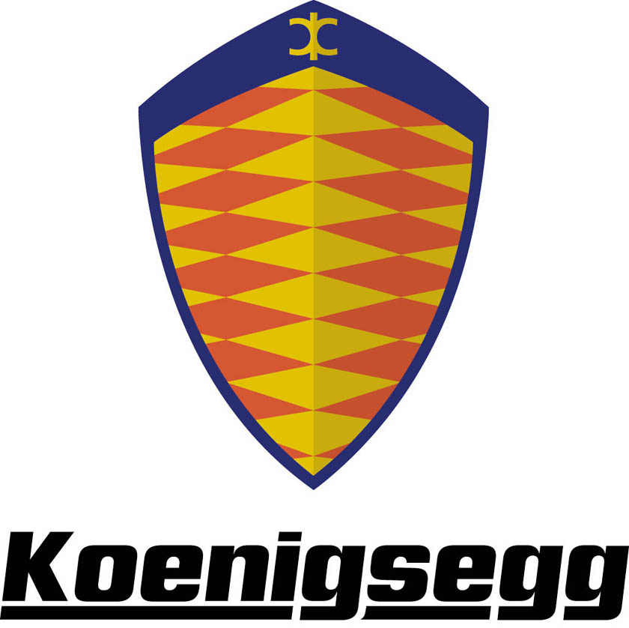

Company History

2004

All development effort was concentrated on the CCR, the new 806 hp model that was presented at the Geneva Motor Show in March. The exhibited vibrant orange car was hailed as one of the true gems of the show. The Koenigsegg CCR features several new components which interact to bring its performance up far beyond that of any other supercar. The CCR will attemt to brake the high speed record, and travel faster than 395 km/h, later this year.

2003

Several improvements both on design and performance was implemented on the 2003 model CC 8S. Modifications on the suspension system was made in cooperation with mr. Loris Biccochi, world renowned testdriver with experience from Lamborghini, Ferrari and Bugatti. Production was halted due to a fire accident, which forced Koenigsegg to move into new premices at the F10 Air Force Base at the outskirts of Ängelholm. BBC Top Gear names the CC 8S the fastest car they have ever tested. Koenigsegg now holds the Guiness World Record for the most powerful streetcar.

2002

The first customer Koenigsegg CC, named CC 8S, was assembled and it was handed over to its proud owner at the Geneva Motor Show in March. This red car was also tested by Koenigsegg´s test drivers on racetracks and roads, to further refine permormance and drivability. While the build-up of the assembly line at the Koenigsegg plant still under way, the team nonetheless managed to build five stunning cars during the year. In September Koenigsegg was launched in Asia, with two cars featuring in a spectacular premiere at the Seoul Car Show.

2001

The silver production prototype CC recieved great attention at it’s presentation at the Paris Motor Show. Articles about it was published in most of the world’s car magazines. It also received several design awards, among them the prestigious German Red Dot award and a prize for excellent Swedish design. The Swedes voted the Koenigsegg CC the Car of the Year in the Swedish magazine Automobil. The Magazine Car and Driver performed a series of test to the car and found it beating the competition on most accounts such as acceleration, lateral g and braking.

2000

The first production prototype vehicle was assembled and tested during the spring and summer. The deadline was set to September 28th, when the finished product met the jury of the world; the Premiere at the Paris Motor Show. Meanwhile, at the Koenigsegg facility a full scale production line for the manufacturing of the cars was being organized.

1999
Since nearly every key part of the Koenigsegg CC is specially designed and unique, highly qualified composite engineers and CAD/CAM engineers were employed. Modelers with experience from SAAB, Bentley and Bugatti created the final body. A three dimensional measuring system with full CAD/CAM capabilities was set up in the modeling workshop.

1998

The Koenigsegg team worked full speed ahead on the specified product model. The car went through 57 different tests in order to comply with international certification regulations. Maintaining a low profile towards the media, all concentration was focused on perfecting the final product. An ideal new facility near Ängelholm in southern Sweden was purchased, and the build up of a series production infrastructure was started.

1997

The Koenigsegg CC prototype is shown at the Cannes film festival and it’s success was immediate. The satisfactory test results and the great media coverage at the Cannes film festival enabled the company to go forward and engage in the creation of finished product. An entirely new car was being brought into the world. Sticking to the basic concept of the prototype, the chassis was now included a carbonfibre monocoque, and a unique module system was developed, so that the car easily can be configured to every desired set-up.

1996

This was a year of heavy testing on racetracks, roads and in the Volvo wind tunnel. Among the well renowned race-car drivers to test the prototype were Picko Troberg, Calle Rosenblad and Rickard Rydell. They were all amazed by its outstanding performance. The concept worked. It was time to introduce the concept to the prospective buyers.

1995

Koenigsegg moved into new premises in Olofström in southern Sweden. Development started and the production of the first prototype was initiated. The newly assembled Koenigsegg team makes an extraordinary effort; in only one and a half years a fully operational prototype was finished, ready for media promotion and evaluation.

1994

The Koenigsegg project was launched. With a long tradition of building high quality cars and a large number of suppliers to the racing car industry, Sweden offered a suitable breeding ground for the development of a world-class supercar.

The concept for this supercar was set from the start, a two-seat mid engine construction with a hardtop, all based on state of the art Formula One technology. A network of competent designers and engineers, with connections both to the Swedish car industry and the universities, was tied together.

