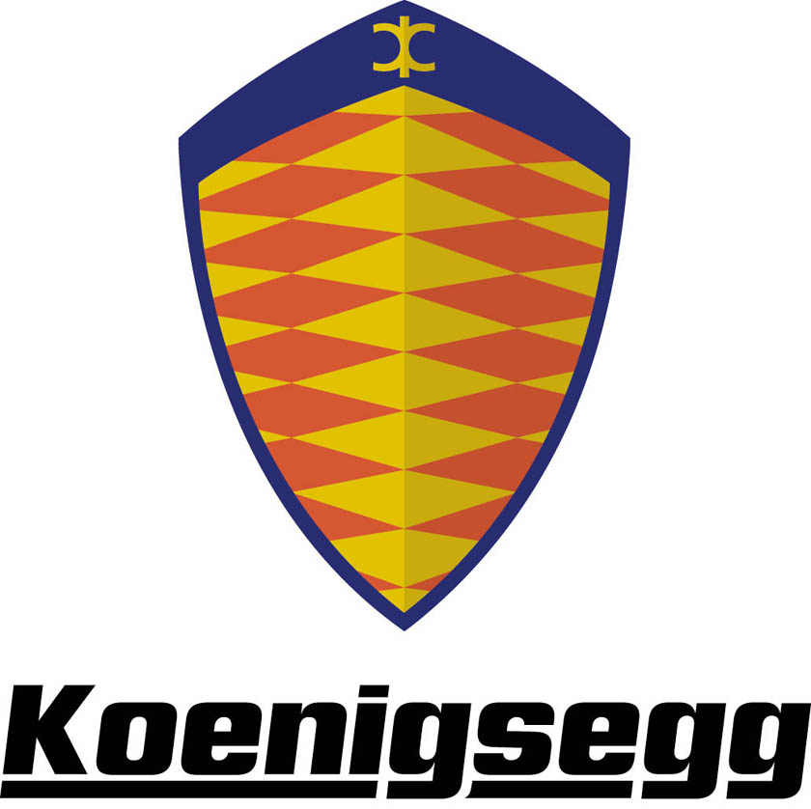

Koenigsegg CCR - Technical Data

Performance

Acceleration: 0-100 km/h (0–62 mph) 3.2 seconds
Top speed: 395+ km/h (242+ mph)
Standing quartermile: 9 seconds, end speed 235 km/h (146 mph)
Braking distance: 31 m (100–0 km/h)
Lateral g-force: 1.3 g
Fuel consumption: Highway travel: 13 l/100 km
Combined: 17 l/100 km

Body

Two-door, two-seater with removable hardtop stowable under the front boot lid. The body is made of preimpregnated carbonfibre/kevlar and lightweight hard-foam sandwich reinforcements.

Dimensions

Ground clearance: 100 mm (3.9 inch)
Fuel capacity: 80 litres (17.6 gallons)
Luggage compartment: 120 litres (26.4 gallons)
Dry weight: 1180 kg

Areodynamics

Cd. 0.297. Frontal area 1.825 m2. Completely flat underside of chassis. Venturi tunnels at the rear of chassis/body.

Chassis

Semi monocoque made of preimpregnated carbonfibre and with honeycomb reinforcements for added stiffness.
Front and rear suspension: Double wishbones, adjustable VPS custom racing shock absorbers, pushrod operated. Anti-roll bar. Electronically adjustable ride height.
Front brakes: Ventilated discs Ø 362 mm, 32 mm wide. 6 piston light alloy calipers. Power assisted. Koenigsegg Advanced Control system. Rear brakes: Ventilated discs Ø 362 mm, 32 mm wide. 6 piston light alloy calipers. Power assisted. Koenigsegg Advanced Control system.

Wheels

Koenigsegg magnesium alloy wheels with centre locking.
Front: 19” x 9.5”
Rear: 20” x 12.5”
Tyres

Michelin Pilot Sport 2. Unidirectional with asymmetric tread pattern.
Front: 255/35–19” (Y)
Rear: 335/30–20” (Y)

Steering

Rack and pinion power assisted steering. 2.7 turns lock to lock. Turning circle: 11 metres.

Engine

Type: V8 cast aluminium, 4 valves per cylinder, double overhead camshafts. Cam cover of carbonfibre.
Displacement: 4.700 cm3.
Compression: 8.6:1
Weight: 215 kg
Lubrication system: Dry sump with unique oil spray piston cooling. Oil cooler.
Oil: SAE 5 W/30 fully synthetic racing.
Oil tank capacity: 12 litres (2.64 gallons)
Induction system: Sequential, multipoint fuel injection. Lysholm twin-screw supercharger with 1.2 bar boost pressure. Intercooler.
Fuel: 98 RON unleaded.
Ignition system: Direct coil on plug. Transistorised.
Power output: 806 bhp at 6.900 rpm.
Maximum torque: 920 Nm (678 ftlb) at 5.700 rpm.
Maximum rpm: 7.600 rpm.

Transmission

Specially developed 6-speed gearbox by Cima. Incorporated internal oil pump and oil cooler. Torque sensitive, limited slip differential.
Clutch: Dual Plate, organic or cintered Ø 215 mm (8.46 inch). Oil-cooled and electronically operated.

Equipment

In standard mode the car is very well equipped with many items that competitors have as options. Many customers, however, want to further equip the car. Therefore we can offer a list of customer options which should fulfil every demand.

Standard equipment

□ Detachable roof panel
□ Climate control
□ Electric rear view mirrors
□ Leather interior
□ Central locking
□ Electrical windows
□ Alarm with immobilizer
□ Toolkit
□ Driver side airbag
□ Power steering
□ Hydraulic ride height control
□ Servo assisted brakes
□ ABS
□ Traction control
□ Stereo with CD-player
□ Tyre pressure sensors
□ Car cover
□ Exhaust system in titanium

Customer options

□ Parking sensors
□ GPS navigation and/or tracking system
□ Telephone system
□ Rearview camera
□Aluminium rear light casings
□4-point safety belts
□ Sequential gearbox
□ Tailor-made suitcases
□ Custom colour leather interior
□ Custom paint colour
□ Additional noise insulation
□ Carbonfibre rear twin fin wing
□ Carbonfiber front splitter
□ Ø 378 mm brake discs, front

Koenigsegg reserves the right to change or amend this information without notice.

