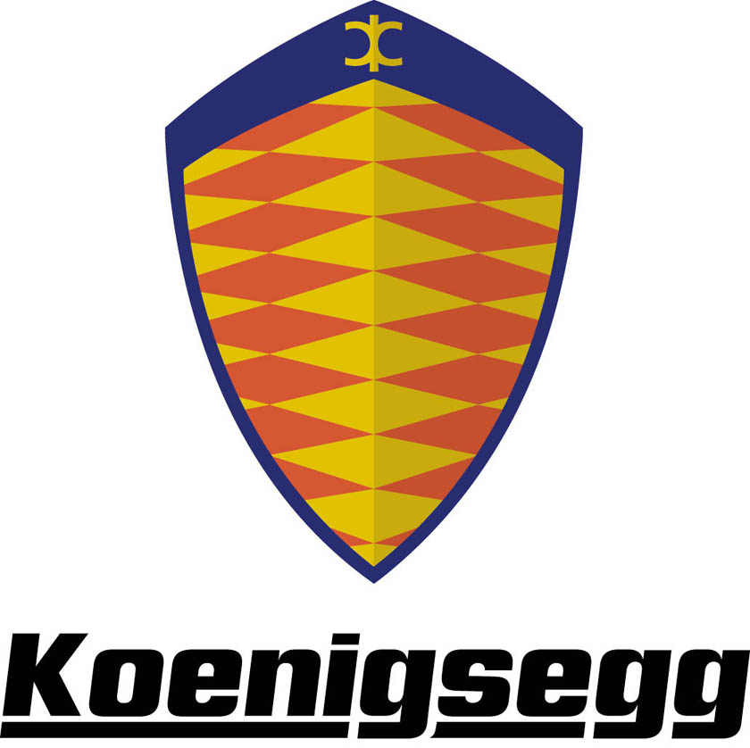

Koenigsegg CC8S - Technical Data

Performance

Acceleration: 0-100 km/h (0–62 mph) under 3.5 seconds
Top speed: 390 km/h (240 mph)
Standing quartermile: 10 seconds, end speed 217 km/h (135 mph)
Braking distance: 32 m (100–0 km/h)

Body

Two-door, two-seater with removable hardtop stowable under the front boot lid. The body is made of preimpregnated carbonfibre/kevlar and lightweight hard-foam sandwich reinforcements.

Dimensions

Ground clearance: 100 mm (3.9 inch)
Fuel capacity: 80 litres (17.6 gallons)
Luggage compartment: 120 litres (26.4 gallons)
Dry weight: 1175 kg

Areodynamics

Cd. 0.297. Frontal area 1.825 m2. Completely flat underside of chassis. Venturi tunnels at the rear of chassis/body.

Chassis

Semi monocoque made of preimpregnated carbonfibre and with honeycomb reinforcements for added stiffness.
Front and rear suspension: Double wishbones, adjustable Öhlins Racing gas-hydraulic shock absorbers, pushrod operated. Anti-roll bar. Electronically adjustable ride height.
Front brakes: Ventilated discs Ø 340 mm, 32 mm wide. 6 piston light alloy calipers. Power assisted. Koenigsegg Advanced Control system. Rear brakes: Ventilated discs Ø 315 mm, 28 mm wide. 4 piston light alloy calipers. Power assisted. Koenigsegg Advanced Control system.

Wheels

Koenigsegg magnesium alloy wheels with centre locking.
Front: 18” x 9,0”.
Rear: 20” x 12,5”.

Tyres

Michelin Pilot Sport 2. Unidirectional with asymmetric tread pattern.
Front: 255/40 ZR 18
Rear: 335/30 ZR 20
Steering

Rack and pinion power assisted steering. 2.7 turns lock to lock. Turning circle: 11 metres.

Engine

Type: V8 cast aluminium, 4 valves per cylinder, double overhead camshafts. Cam cover of carbonfibre.
Displacement: 4.700 cm3.
Compression: 8.6:1
Weight: 210 kg
Lubrication system: Dry sump with unique oil spray piston cooling. Oil cooler.
Oil: SAE 5 W/30 fully synthetic racing.
Oil tank capacity: 12 litres (2.64 gallons)
Induction system: Sequential, multipoint fuel injection. Supercharging with 1.2 bar boost pressure. Intercooler.
Fuel: 98 RON unleaded.
Ignition system: Direct coil on plug. Transistorised.
Power output: 655 bhp at 6.800 rpm.
Maximum torque: 750 Nm (550 ftlb) at 5.000 rpm.
Maximum rpm: 7.300 rpm.

Transmission

Specially developed 6-speed gearbox by Cima. Incorporated internal oil pump and oil cooler. Torque sensitive, limited slip differential.
Clutch: Dual Plate, organic or cintered Ø 215 mm (8.46 inch).

Equipment

In standard mode the car is very well equipped with many items that competitors have as options. Many customers, however, want to further equip the car. Therefore we can offer a list of customer options which should fulfil every demand.

Standard equipment

□ Removable roof panel
□ Climate control
□ Electric rear mirrors
□ Leather interior
□ Central locking
□ Electrical windows
□ Alarm with immobilizer
□ Toolkit
□ Driver side airbag
□ Power steering
□ Hydraulic ride height control
□ Servo assisted brakes
□ ABS
□ Traction control
□ Stereo with CD-player

Customer options

□ Parking sensor
□ GPS navigation and/or tracking system
□ Telephone system
□ Rearview camera
□ Car cover
□ Carbonfibre rear wing
□ Aluminium rear light casings
□ 4-point safety belts
□ Sequential gearbox
□ Tailor-made suitcases
□ Twin Fin Wing for optimal rear visibility and downforce
□ Exhaust manifold in titanium (weight decrease 15.5 kg)
□ Ø 362 mm brake discs, front and rear
□ 19” front wheels

Koenigsegg reserves the right to change or amend this information without notice.

